Current Market Needs
- Demand for rapid, scalable content delivery across OTT and gaming platforms
- Artistic integrity remains non-negotiable for audience engagement
- Studios seek hybrid pipelines that automate while preserving creativity
- Ghibli introduces AI + Artist feedback system to meet this demand

Competitor Landscape
- Pixar: AI-driven lighting, camera workflows
- Disney: Deep learning for facial animation and rigging
- Netflix & DreamWorks: Cloud-based AIassisted rendering
- Competitors focus more on automation than creative control

Ghibli’s Hybrid Advantage
- Uses modular AI microservices (Coloring, Inbetweening, Shading)
- Artist feedback loops at every stage
- Ensures consistent style and artistic fidelity
- Balances speed, quality, and creativity

Benchmarking Competitors

Metric | Pixar/Disney AI | Ghibli Hybrid AI
Render Quality | High, often uniform | High, artist-guided, stylized
Turnaround Time | Fast via automation | Fast + real-time iteration
Cost Efficiency | High infrastructure cost | Modular, scalable, costflexible

Recommendations
- Promote ethical AI that supports rather than replaces human artists
- Invest in collaborative platforms with integrated artist feedback
- Standardize and modularize AI microservices for animation
- Encourage open-source innovation in the animation pipeline domain

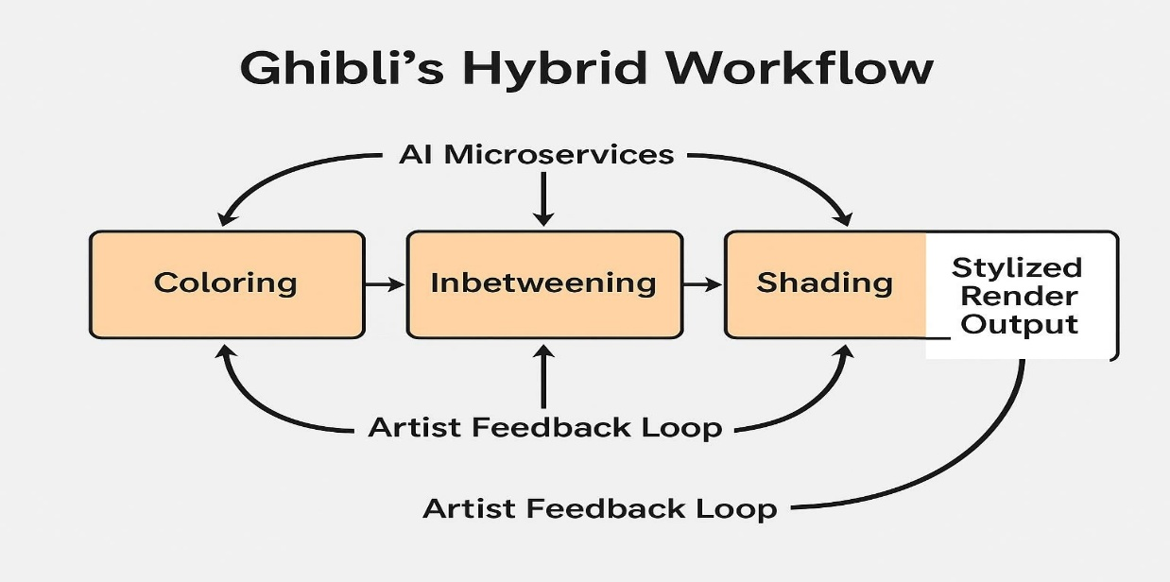
Ghibli’s Hybrid Workflow (Diagram)

